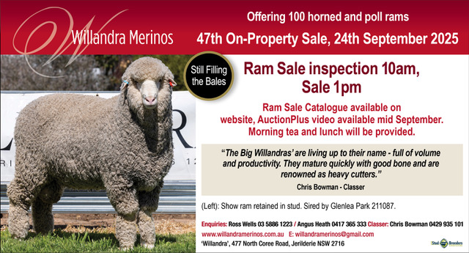

Dear clients and friends,

I feel like I am the luckiest man alive. Grandson, Angus, has taken the job of managing a merino stud ‘head-on’ and is assisted greatly by Caroline’s input, and if the pressure gets too great, Craig gets off the tractor to lend a hand. In conjunction with Chris Bowman, they make a great team.

It has got to the point where the greatest assistance I can give is to keep out of the way! As long as they keep taking me to shows and my greatest wish is fulfilled, this being to see the two little girls (my great granddaughters) holding sheep at the shows, I will be happy.

I guess this year has given us a bit of a shock after going through 5 years of very high productivity for both grain and stock. Albeit a couple of those years were difficult due to too much rain. Up until the middle of August we have received 6 inches of rain ( 2 inches fell in March).

We have been here for 65 years, with the first 50 years producing a lot more drought years than the last fifteen. With the long-range forecasts suggesting the September-November period could see well above average rainfall for the Eastern half of Australia, maybe it might turn out okay. I would not bet on it!!

Lamb and Mutton prices- unbelievable

I suppose you might say we should have seen it coming, yes $8-$11 for lamb not the $12-$13 and yes, $5 for mutton not $8-$9. Should we sell our merino wether lambs early? I would say yes certainly, taking into consideration the season, we are not out of the woods yet. Clients, the Sleigh family, ‘Kooringal’, sold a run of 1,000 April drop 26kg lambs on AuctionPlus last week for $163. These lambs did not cost very much to get them to that stage.

Based on these prices, 4 good 10 month old wether lambs - $1,000 or 6 good wether lambs straight off their mothers for $1,000 - much easier and very much more profitable than getting an eighteen month old ram ready to sell at $1,000.

Spring Sales

A lot of the cull young ewes and the mature age ewes have been sold to the meat buyers. Due to this, although seasonal conditions will have a bearing, we could see a period of extreme demand for replacement ewes during the Spring.

Wool Prices

Won’t have any bearing on the price of sheep in the short term. If you want to take a punt, just hang in there with your Merino sheep. Due to a sell-off of a significant number of the Merino flock we will eventually see the supply to demand balance come back in to play. If the world turmoil steadies, we could see a sharp rise.

Rams

My father wrote every year that his rams were the best they had ever been. I am going to write that they are as good as usual. We will continue to breed Horn rams as well as our Polls. Due to the cost pressures of today I can’t see any reason to change the type that we are noted for – large framed, heavy cutting, quality white wool sheep that have the ability to rear quality wether lambs, selling for high prices.

Hoping this note finds you all well and that the season picks up. I look forward to catching up at the ram sale.

All the best,



Ross Wells

P.S. Just a little something when you are thinking about Merino sheep. Three things that are maybe equal in importance:

Have a plan, but it must be flexible-

* Genetics
* Property and stock management
* Marketing

All very important.