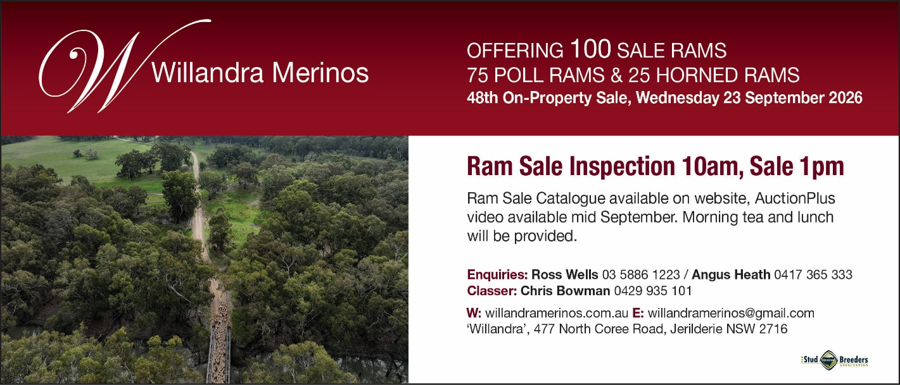
31st August, 2026
Dear clients and friends,
Just a brief note to bring you up to speed with what is going on, here at Willandra. The greatest change has been brought about by the loss of ‘Our Rock’ – Craig, in a farm accident on the 14th December last year. It has left a great hole in all our lives.

Caroline has been marvellous, in how she has coped with the great responsibility she has had to deal with from day to day. She has had wonderful support from close friends, who have helped her get through what has been a difficult time.

Angus has taken the job head-on and has been well supported by Aaron Stockton and Joe Gahan, both capable men. Our cropping programme is very ably carried out by Wayne Kerr, a dedicated farmer with many years of experience. Wayne had been assisting Craig for a couple of years so was familiar with our whole farm operation. Angus is exceptionally lucky to have Chris Bowman, who with a wealth of experience in the Merino industry, is mentoring Angus and helping steer the breeding programme.

The year has been a good one seasonally and from the point of view of sheep management. This has been reflected in the percentage of lambs we have achieved, with most mobs coming up with 120 – 125%. Reports indicate that most people have achieved good percentages.

We have had an outstanding year in the show ring starting at Hay where we took home the Best in State Merino Hogget award, with our medium wool Horned ram lamb. Bendigo Show, I guess, was the proudest we have been of our team of 14 sheep who won 14 broad ribbons. In the National Pair competition, we came first with our Poll pair and third with our Horn pair. Collinsville were second. We won the Champion and Reserve Champion March Shorn Ewe of the Show. Out of 35 entries in the production classes we won the two overall awards for the Champion Australian Merino All-Purpose Ram and the Australian Merino Meat Ram. Dubbo was another achievement highlighted by winning the fiercely contested Pen of Three Rams for the first time, and winning the Most Successful Exhibitor.

We have already had some very good stud sales this year. At Bendigo, Argentinian, Emiliano Lopez of Cerro Chenque Merino Stud, was taken by our sheep and has privately purchased the Grand Champion Fine Medium March Shorn Ram for $35,000 and the Hay Best in State Horned Ram for $30,000. He also purchased the Reserve Champion March Shorn Ewe of the Show at Bendigo for $10,000.

Also at Bendigo, Jack Beaton, from Kevlyn Stud, Vic., was attracted to another Fine Medium Wool Poll Ram with 17.2 micron wool, comfort of 99.9% and eye muscle of 42. A particularly well-balanced ram, Jack purchased the ram for $15,000.

Ram Sale
We will be offering 75 Poll Rams and 25 Horned Rams. There are some very outstanding rams throughout the draft and we are pleased with their overall quality. There will be a small number of rams to top up purchases straight after the sale, if required, at $1,750.

Grade rams at $1,000 and $1,500, will be available as from 29th of September, the following week.

We would like to thank you for your loyal support over the many years. I look forward to catching up with you for a yarn on sale day.

Here’s hoping the present good seasonal conditions continue on, for the rest of the year.

All the best,

Ross Wells

